Business CareWare


How To Install and Setup the CABS FSI on Client Site
How To Document

Document Changes

Date | Version | Change Description | Changed By
02/02/2017 | 1.0 | Original Version | TT

Table of Contents
1 Introduction 3
2 Installation/Update of the CABS FSI Functionality 3
3 CABS FSI Configuration 6
3.1 Customer Specific Configuration 6
3.2 SQL Server Pre-Requisites 7

Introduction

This document provides a description of how to install and/or update the CABS FSI functionality as well as how to configure it.

Installation/Update of the CABS FSI Functionality

- All SQL scripts should be uncompressed and copied to an installation directory that MS SQL Server Management Studio has access to.

- In MS SQL Server Management Studio, open the script file called FSI_Install.sql. Ensure the query window is connected to the target database. This script is responsible for installing or updating the FSI components.

Before this script can be run it must be modified. This is clearly indicated near the top of the script as illustrated in the figure below:
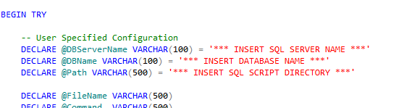
Figure 1 - Site specific Configuration

Replace the ‘*** INSERT …. ***’ strings with the appropriate data as illustrated in the Figure below:
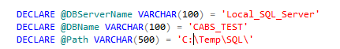
Figure 2 - Example User Specified Configuration

Ensure that the @Path variable ends with a backslash (\) character.

- The install script uses xp_cmdshell which is not always enabled on a SQL Server.

  - Check if xp_cmdshell is enabled by running the following SQL:

SELECT CONVERT(INT, ISNULL(value, value_in_use)) AS config_value
FROM sys.configurations
WHERE name = 'xp_cmdshell' or name = 'show advanced options'

If the result is as below:

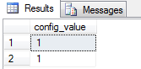
Figure 3 - xp_cmdshell Enabled

The installation script can be run.

If not run the following SQL:

EXEC sp_configure 'show advanced options', 1
GO
RECONFIGURE
GO

EXEC sp_configure 'xp_cmdshell', 1
GO
RECONFIGURE
GO

  - Execute the FSI_Install SQL script.

  - The Messages Tab will display progress information and whether or not the script ran successfully:

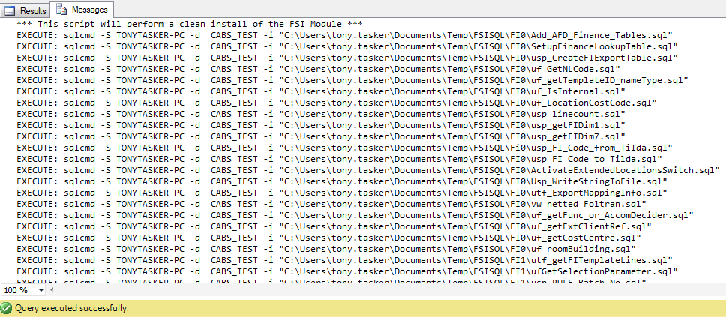
Figure 4 – FSI Installation Messages

  - The Result Tab will display diagnostic information should any errors or issues be detected:

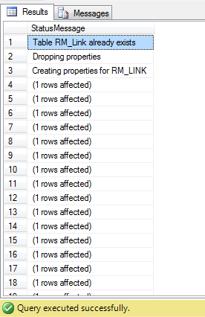
Figure 5 – FSI Installation Status Messages

Issues will normally be indicated on a line that starts with “msg….”

  - If the sp_configure commands were previously run then reset the values.

Run the following SQL:

EXEC sp_configure 'xp_cmdshell', 0
GO
RECONFIGURE
GO

EXEC sp_configure 'show advanced options', 0
GO
RECONFIGURE
GO

  - Check if xp_cmdshell is disabled again by running the following SQL:

SELECT CONVERT(INT, ISNULL(value, value_in_use)) AS config_value
FROM sys.configurations
WHERE name = 'xp_cmdshell' or name = 'show advanced options'

If the result is as below:

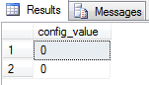
Figure 6 – xp_cmd_shell Disabled

CABS FSI Configuration

Customer Specific Configuration

In the location where the install files have been extracted there should be a script that adds FSI configuration data to the database. The name will be of the format of “COMPANY NAME Configuration.sql” with “COMPANY NAME” being replaced with client name. This will be located in a directory called “FIConfig”.

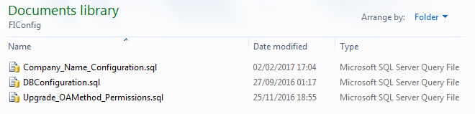
Figure 7 - Company Specific FSl Configuration Script

This data will/could include FSI template definition data, FSI configuration data and any other FSI specific SQL.

In MS SQL Server Management Studio, open the script file called. Ensure the query window is connected to the target database.

Before this script can be run it must be modified. This is clearly indicated near the top of the script as illustrated in the figure below:

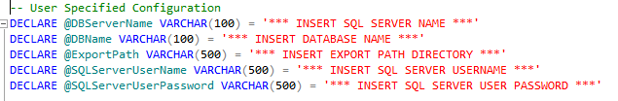
Figure 8 - Site specific Configuration

Replace the ‘*** INSERT …. ***’ strings with the appropriate data as illustrated in the Figure below:

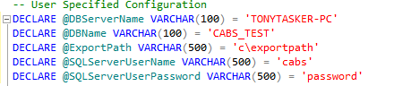
Figure 9 - Completed Site Specific Configuration

Execute the script.

SQL Server Pre-Requisites

To function correctly the FSI functionality requires certain elevated SQL Server settings to be in place. These are to enable a text file to be created and updated.

The following script, in the “FIConfig” directory needs to be run.

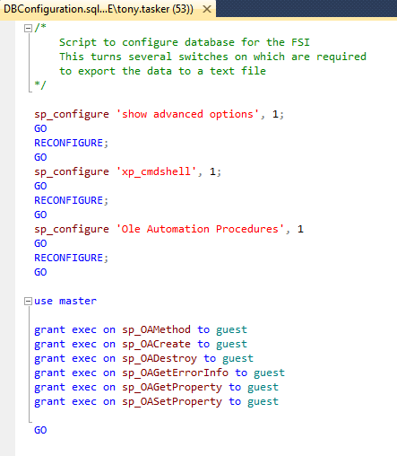

Figure 10 - FSI Required SQL Server Setings

